JAVA CODE:
class VarArgs
{
// method with variable length arguments
static void add(int... numbers)
{
int sum = 0;
for (int n : numbers)
{
sum = sum + n;
}

System.out.println("Sum = " + sum);
}

public static void main(String args[])
{
add(2, 3);
add(1, 2, 3, 4);
}
}

OUTPUT:
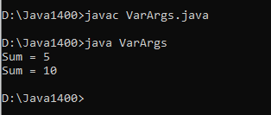

JAVA CODE:
class Person
{
String name;
int age;

// constructor
Person(String name, int age) //Parameters
{
this.name = name; // this refers to class variable
this.age = age;
}

void display()
{
System.out.println("Name: " + name);
System.out.println("Age: " + age);
}

public static void main(String[] args)
{
Person p1 = new Person("Rahul", 20);
p1.display();
}
}

OUTPUT:
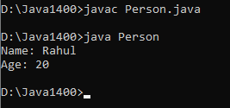

JAVA CODE:
class Counter
{
static int count = 0;

Counter()
{
count++;
}

static int getCount()
{
return count;
}
public static void main(String[] args) {
Counter c1 = new Counter();
Counter c2 = new Counter();
Counter c3 = new Counter();

System.out.println("Number of objects: " + Counter.getCount());
}
}

OUTPUT:
